Chapter 3 John Fullick II the Younger – Civil War

It was not long afterwards that the Civil War began. It would divide the country. Young John, my 8-x great grandfather, almost certainly took no active part in the fighting, but nowhere in the country was isolated from its impact. The conflict was the result of several social, economic, political and religious changes, but the immediate cause was the attempt by Charles I to impose the liturgy of the English church in Scotland. To raise money for the war that followed, the king summoned Parliament. But in return for its support Parliament demanded reforms. The political quarrel developed into civil war with the king’s followers – the Cavaliers – fighting with those supporting Parliament – the Roundheads. Some areas of the country sided with the king and others, like London, with Parliament. But allegiances were complicated. Families could be divided and even some members of Parliament sided with the king.

By the time young John was fourteen years old, Parliament was supported by the Scottish army and won the crucial Battle of Marston Moor. Another confrontation took place on 13 December 1643.

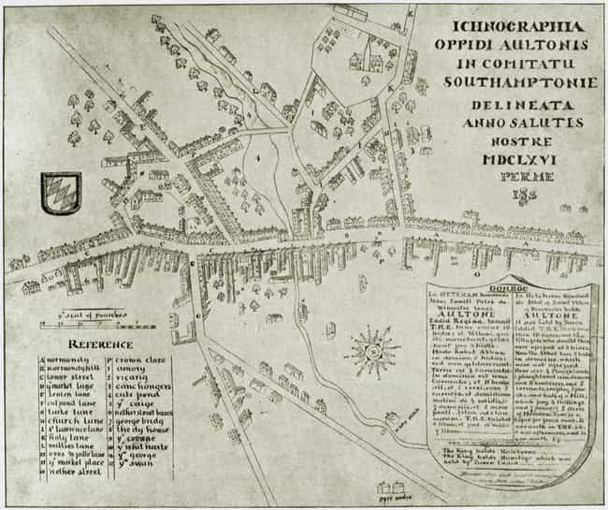

Parliamentary forces led by Sir William Waller led a surprise attack on a winter garrison of Royalist infantry and cavalry in the Hampshire town of Alton serving under the Earl of Crawford. At dawn, as Lord Waller's army approached, Crawford fled with the cavalry to Winchester, leaving Colonel Richard Boles with only the infantry. Outnumbered and overwhelmed in the Battle of Alton, the Royalists sought refuge in the Church of St Lawrence, but this did not save them. Many were killed in the church and the marks of pikes and musket balls remain in the walls today. News of the Battle of Alton must soon have reached John and the other Bramshott villagers just a few miles away.

Following their victory at Alton, the Parliamentarians marched south east to Arundel, a larger and more formidable Royalist site. They were successful here too. Oliver Cromwell then defeated the king’s army at Naseby in 1645 and Charles I surrendered to the Scots who turned him over to Parliament. He rejected Parliament’s conditions for a return to power and was then seized by the more politically radical army. However, he escaped and established an alliance with the Scots.

Whilst these national events played out, locally many aspects of life in Bramshott must have continued much as before. John’s mother, Elizabeth, never remarried and she spent the rest of her life in the same village. She is likely to have been the “widow Fullick” who appeared in the manorial court rolls in 1647 for having encroached on the manorial waste presumably as she tried to acquire some more land for growing crops.

A second war took place in 1648, when my 8-x great grandfather turned nineteen. Now the army and Parliament were fighting against Scotland and the king. The Royalists were soon defeated for the second time and the army took control. Parliament was purged and the remaining Rump Parliament tried Charles I for treason. He was found guilty and on 30 January 1649 he was executed in Whitehall – in a turn of events that probably shocked most people. Following this, England was declared a Commonwealth and it was during this period that John’s mother died. She was buried in Bramshott churchyard on 25 July 1652 a matter of months before Oliver Cromwell became a virtual dictator as Lord Protector.

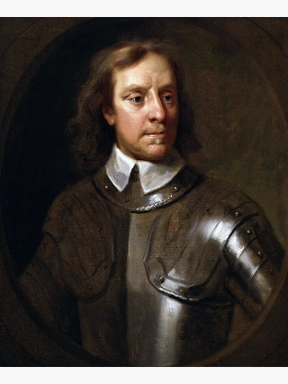

Two years later the commander of the Scottish army marched into London. He recalled Parliament and Charles II was restored to the throne. He arrived back in London on 29 May 1660, his 30th birthday. The restoration was generally warmly welcomed and may have been marked by celebrations in Bramshott itself.

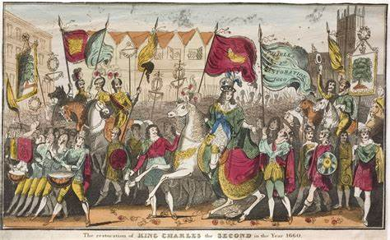

John would then have been thirty-one – a year older than the new king.

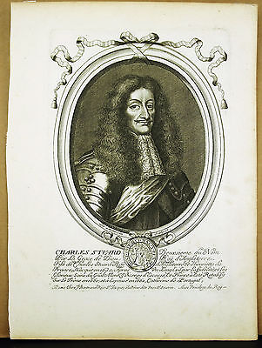

The Civil War that John had lived through affected everyday life in a number of ways. Just one of these was the fact that most parish registers were kept poorly, or not at all. This is certainly true of the Bramshott registers where there are no surviving records between 28 November 1653 and 4 April 1665[1]. This is unfortunate because it was probably during this period that John’s marriage took place and his eldest children were baptised.

So, we are left with only fragmentary evidence of the Fullick family during this period with the most prominent figure being an Edmund Fullick sitting in the manorial court in Bramshott in 1647 and probably also appearing in the parish’s Hearth Tax assessment of 1665. This tax was levied twice a year on Lady Day and Michaelmas during the 1660s and 1670s and the returns list each householder along with the number of hearths they had. The number of hearths reflects the wealth of the occupier and could be assessed by counting chimneys. Poorer people like Edmund with just one or two hearths who occupied houses or land worth less than a pound a year, owned property worth less than ten pounds, paid neither church nor poor rates, received poor relief or who lived in almshouses or hospitals, were excused payment. As he sat in the manorial court, he was probably Richard’s son having inherited his father’s tenancy which made him John’s cousin.[2]

We do know that our John married even though we don’t have a marriage record and from her burial record, we think that his wife was named Katherine[3]. She is likely to have been a few years younger than her husband. A date of around 1660 is plausible for the wedding, although the marriage could have taken place as early as late 1653 (when John would have been twenty-four). It’s likely that John would have waited until he was established in his trade before contemplating marrying though so he might well have been a bit older. We don’t know what his occupation was. We can probably assume that he wasn’t apprenticed to his father but as he had three sons who were butchers, it’s possible he was a butcher too and that the resources had been found to apprentice him – perhaps to a relative – meaning he combined this with agricultural work.

Whenever the marriage took place, John and Katherine probably didn’t have special wedding clothes, but Katherine would have worn a clean linen shift with drawstrings at the neck and wrists as her undergarment whilst John would have had a clean shirt. Over her shift, Katherine probably wore a woollen petticoat which fastened at the front so it could be let out in the future when she was pregnant. Her bodice was laced loosely and around her neck she wore a linen collar. Once she was married her hair, which would have been worn loose whilst she was single, was covered with a coif. And once she was busy running a household, she would have worn an apron over her petticoat to keep it clean. Meanwhile John would have worn a sleeveless woollen doublet or jerkin along with breeches over hose and he probably had a hat of some kind perhaps a skull cap or a felt hat.

After marriage, Katherine would have been responsible for keeping the family’s clothes clean and no doubt, as was traditional, she did her washing on Monday. Wet washing was dried in the sun or in front of the fire. Katherine would have known how to spin and weave cloth and to be able to make simple linen garments. Like previous generations of women, she would have had lots of household tasks to carry out even though she was probably soon pregnant.

John and Katherine had several children together. The eldest recorded in the Bramshott parish registers is Edward (or Edmund) baptised on 29 September 1665[4] and he is my 7-x great grandfather. His birth coincided with the year of the Great Plague which hit London (less than fifty miles away) particularly badly. That summer had been very hot and both the rats and the disease-carrying fleas they hosted bred rapidly. This nursery rhyme has its disturbing origin in the plague.

*Ring-a-ring of roses,*

*A pocket full of poses,*

*Attishoo, attishoo,*

*We all fall down.*

The disease was at its worst that September and the number of deaths only declined as winter approached. However, the Great Fire of London in the following year, whilst also frightening and destructive, ensured that plague was never again such a major killer in the capital.

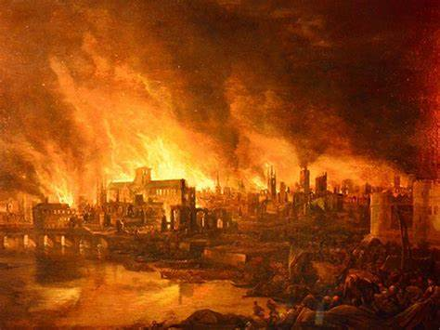

Edward was probably not the eldest child of his parents’ marriage. Typically, the first two children would have been named after their parents, but if there was a Katherine, she must have died young. However, a son named John might be the adult named John Fullick who appears later in the church registers. We have evidence of adults named Thomas and Ann too and they might also be part of this family.[5] If John and Katherine had married as early as 1655, there would have been time for four children to have been born before Edmund in 1665 - allowing for a two-year gap between them - and if a baby died young, that gap could shorten.

As in previous generations, the household would probably have been expected to be largely self-sufficient. Mixed farming both growing grain and keeping sheep and cattle was common and the land would have been ploughed by horses or oxen. Fodder was grown to feed the animals and they provided manure as a fertiliser. Fruit and vegetables were planted and pigs and poultry also featured as part of the household economy. Kitchen scraps and other ‘waste’ could be fed to these so nothing was wasted. Crop rotation helped improve yields and fuel would have been gathered locally. There continued to be a communal aspect to food production as Hampshire was part of the champion landscape with large, centralised villages and shared open fields.[6]

Following my 7-x great grandfather, came several more children whose baptisms are also recorded. When Edward was three, his brother William was born[7] and Katherine (perhaps the second of that name) followed three years later.[8] She was the last child to survive and her three younger siblings all died before their first birthdays. By the time they were born their mother was around forty years old and perhaps no longer strong enough to bear healthy children.[9].



Those siblings, like Edward, who did survive were regarded by their parents as mini-adults rather than children and took on tasks that helped in the running of the household as soon as they were big and strong enough. So, they probably had few opportunities for play. If the Fullick children did have any toys these would probably have been homemade ones – perhaps hoops for rolling, a bat which could be used to hit a cork covered in feathers, a spinning top, or a simple wooden doll. There were traditional fairs as well as pedlars and chapmen who travelled around with goods to sell so perhaps simple toys could have been purchased there too.

By 1679, when Edward was about fourteen years old, he was probably already training for his future occupation and if his father was indeed a butcher, he could have begun to teach the skills to Edmund. Otherwise, he must have been apprenticed to a local butcher as we know that he later followed that occupation.

It was this same year that John Fullick married Ann Upsull in the village church[10] and possibly this was the marriage of the Edward’s eldest brother. For most people, this was the ideal they aimed for - marriage and the setting up of an independent household. Culturally, marriage was highly favoured, although some people did remain single and we’ll find some examples as we move through the family story. There was a belief that marriage should be based on love and there were gendered expectations about the roles with the woman obeying and the man providing and protecting.[11]

Edward marked his fifteenth birthday a few months before his father died on or around Christmas Day making this a rather sombre season for the family. John Fullick was only just over fifty when he died. He was buried in Bramshott on 29 December 1680[12] with his body wrapped in woollen cloth before he was interred. This was a requirement of the Parliamentary Acts of 1667 and 1678, which were intended to help the wool trade.

No corpse:

*shall be buried in any shirt, shift, sheet or shroud or anything whatever made or mingled with flax, hemp, silk, hair, gold or silver or in any stuff other than what is made of sheep’s wool only.*

The Act was amended in 1678 to make it easier to enforce and imposing a penalty of five pounds, so witnesses were required to swear affidavits that the law had been followed.

So we have another generation in which my Fullick ancestor was left without a father during his teenage years. This time though my ancestor probably had some older brothers who might have been able help him out and perhaps enabled him to complete his training as a butcher.

1. There is a note saying the records for these dates were made in a different register. That has been lost. St Mary, Bramshott, Register of baptisms, marriages and burials 1560-1652, 1665-1728, Hampshire Record Office, 57M75/PR1, images on Family Search https://www.familysearch.org/ film 1041172 item 3, digital images DGS 7908499, image 111.
2. There are a few entries in the Bramshott parish registers which I have not yet managed to attach to individuals but which may relate in some way to this Edmund. St Mary, Bramshott, Register of baptisms, marriages and burials 1560-1652, 1665-1728, Hampshire Record Office, 57M75/PR1, images on Family Search https://www.familysearch.org/ film 1041172 item 3, digital images DGS 7908499. An Edmond son of Edmond was baptised on 22 January 1624 image 103. As mentioned in the previous chapter, an Edmond married Jane Scriven on 16 October 1626 image 104. A Jone buried 11 July 1645 might be this Jane. Then Barbara daughter of Edman was baptised 13 May 1652 and buried 10 May 1679. This could be a child of the Edmond baptised in 1623.

   There are also four burials which I haven’t yet assigned to particular individuals. Two women simply named as Widow Fullock/Fullok were buried 8 July 1620 (image 105) and 25 Jul 1652 (image 111). Joane Fullock widow was buried 24 May 1631 (105). Mary Fullocke was buried 27 June 1636 (image 107).
3. This is because there is a burial of a Katherin Fullock widow in Bramshott on 29 Aug 1689 eight years after John’s death and there is daughter Katherine baptised in 1671. Unfortunately, there doesn’t appear to be any other evidence beyond these two records – so there is not complete certainty on this point. I have taken her forename as Katherine in this account though. It has also been suggested that she was Katherine Aylinge, though it is not clear to me what evidence there is for this. If her surname was Aylinge, then Katherine was probably either the daughter of John Aylinge and baptised in Headley on 3 April 1631 or the daughter of Richard Aylinge and baptised in Bramshott on 27 May 1632.
4. Only the father, John, is named in all the baptisms in the Bramshott registers discussed in this chapter.

   St Mary, Bramshott, Register of baptisms, marriages and burials 1560-1652, 1665-1728, Hampshire Record Office, 57M75/PR1, images on Family Search https://www.familysearch.org/ film 1041172 item 3, digital images DGS 7908499 image 112
5. However, we need to bear in mind the presence of the adult Edmund in the parish who might also have had more unrecorded children too.
6. Jane White ‘Land and People’ in A Social History of England 1500-1750 edited by Keith Wrightson Cambridge University Press 2017 pp.155-156
7. baptised on 25 November 1668 in Bramshott Jane was baptised on 7 December 1675 and buried just four days afterwards, whilst George, who was baptised on Christmas Day in 1676, was buried the same day . St Mary, Bramshott, Register of baptisms, marriages and burials 1560-1652, 1665-1728, Hampshire Record Office, 57M75/PR1, images on Family Search https://www.familysearch.org/ film 1041172 item 3, digital images DGS 7908499 image 113
8. baptised on 30 March 1671St Mary, Bramshott, Register of baptisms, marriages and burials 1560-1652, 1665-1728, Hampshire Record Office, 57M75/PR1, images on Family Search https://www.familysearch.org/ film 1041172 item 3, digital images DGS 7908499 image 114
9. Little Jone was baptised on 11 April 1673 and buried a few months later on 21 July St Mary, Bramshott, Register of baptisms, marriages and burials 1560-1652, 1665-1728, Hampshire Record Office, 57M75/PR1, images on Family Search https://www.familysearch.org/ film 1041172 item 3, digital images DGS 7908499 image 115, 116, This rapid loss of three children in a row is a bit more unusual suggesting a possible health issue. However, about a quarter of children did die before the age of ten. See Linda Pollock ‘Little Commonwealths I The Household and Family Relationships’ in A Social History of England 1500-1750 edited by Keith Wrightson Cambridge University Press 2017 pp.61
10. Needs reference
11. Linda Pollock ‘Little Commonwealths I The Household and Family Relationships’ in *A Social History of England 1500-1750* edited by Keith Wrightson Cambridge University Press 2017 pp.66-67
12. St Mary, Bramshott, Register of baptisms, marriages and burials 1560-1652, 1665-1728, Hampshire Record Office, 57M75/PR1, images on Family Search https://www.familysearch.org/ film 1041172 item 3, digital images DGS 7908499 image 117